
RAMAIAH
Institute of Technology
USN | 1 | M | S

(Autonomous Institute, Affiliated to VTU)
(Approved by AICTE, New Delhi & Govt. of Karnataka) Accredited by NBA & NAAC with ‘A’ Grade

SEMESTER END EXAMINATIONS – JULY / AUGUST 2021
Program | : | B.E. : Common to all Programs | Semester | : | I / II
Course Name | : | Basics of Civil Engineering and Mechanics | Max. Marks | : | 100
Course Code | : | CV14/CV24/CV101/CV201 | Duration | : | 3 Hrs

Instructions to the Candidates:
- Answer one full question from each unit.
- Missing data can be assumed suitably.

 |  | UNIT- I
1. | a) | List the various branches of civil engineering and explain the scope of: i) Structural engineering ii) Water resources engineering iii) Geotechnical engineering. | CO1 | (10)
 | b) | Explain the impact of infrastructural on the socio-economic development of the Country. | CO1 | (10)
2. | a) | Discuss the role of civil engineer in the infrastructure development. | CO1 | (10)
 | b) | Mention the properties and application of Prestressed concrete and Steel. | CO1 | (10)
 |  | UNIT – II
3. | a) | Four Coplanar Concurrent forces acting at a point are as shown in Fig. 3(a). One of the force is unknown and its magnitude is as shown by “F”. The resultant has a magnitude of 500N and is acting along x axis. Determine the unknown force “F” and its inclination with respect to x axis.  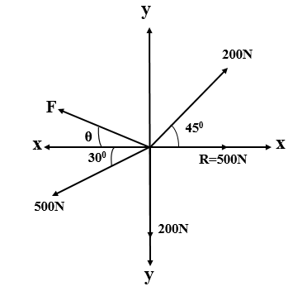  Fig. 3(a) | CO2 | (10)
 | b) | Explain the following:  - Composition of forces  - Principle of transmissibility of forces. | CO2 | (05)
 | c) | Define Couple and Mention its characteristics. | CO2 | (05)
4. | a) | State and prove Varignon’s principle. | CO2 | (10)
 | b) | Determine the magnitude, direction of the resultant force for the force system shown in Fig. 4(b). Locate the resultant force with respect to point D  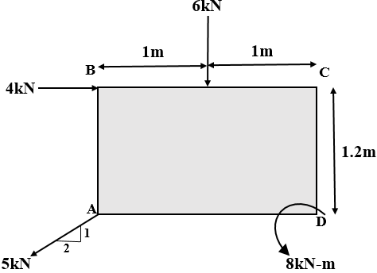  Fig. 4(b) | CO2 | (10)
 |  | UNIT – III
5. | a) | Compute the tensions in the strings AB, BC and CD as shown in the Fig.5(a).  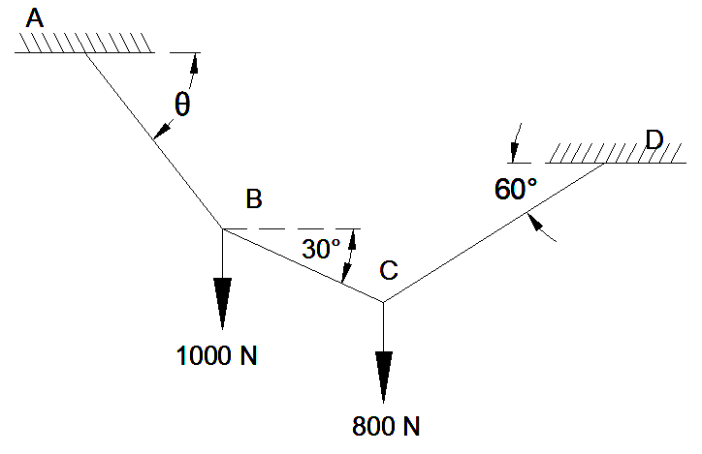  Fig.5(a) | CO3 | (10)
 | b) | Determine the reactions at contact points P, Q, R and S for the system shown in the Fig.5 (b). The radii of the spheres 1 and 2 are, 20mm and 30mm respectively in Fig.5(b).  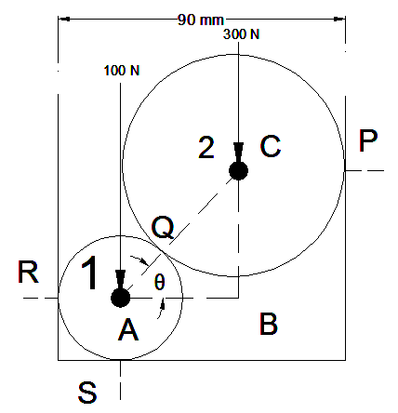  Fig.5(b) | CO3 | (10)
6. | a) | List out the type of loads with neat sketches. | CO3 | (05)
 | b) | Find the support reaction of beam loaded as shown in the Fig.6(b).  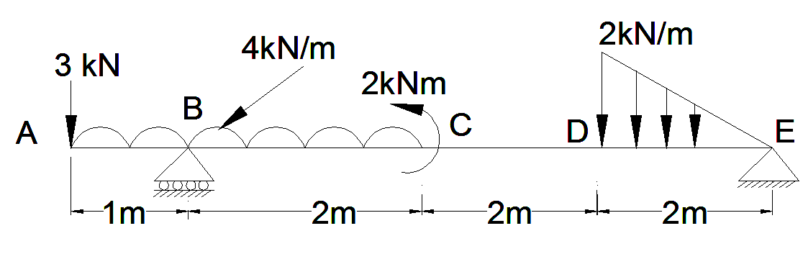  Fig.6(b) | CO3 | (15)
 |  | UNIT – IV
7. | a) | Derive an expression for Centroid of a Triangle. | CO4 | (10)
 | b) | Determine the centroid respect to X and Y axis for the figure shown in Fig. 7(b).  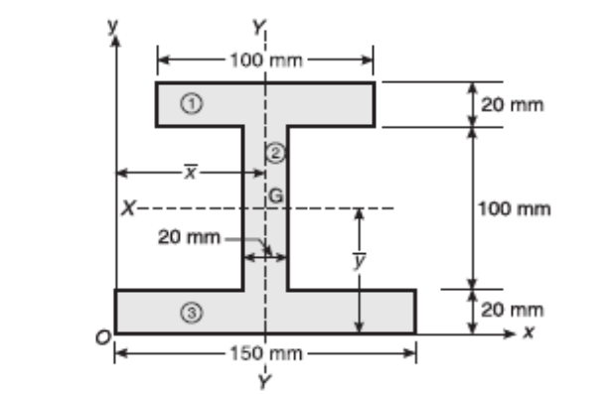  Fig.7(b) | CO4 | (10)
8. | a) | Derive an expression for Moment of Inertia of a Rectangle. | CO4 | (10)
 | b) | Determine the moment of inertia of the plane lamina about the x-axis shown in the Fig.8(b).  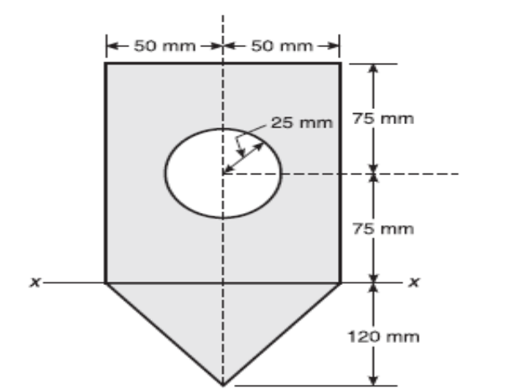  Fig.8(b) | CO4 | (10)
 |  | UNIT – V
9. | a) | State the laws of friction? Explain types of friction with examples? | CO5 | (08)
 | b) | Find the force ‘F’ just required to slide the block Q in arrangement shown in Fig.9(b). Find also tension in cable. Take, Weight of block P = 1000N,Weight of block Q = 2000N m = 0.4  (for all contact surfaces)  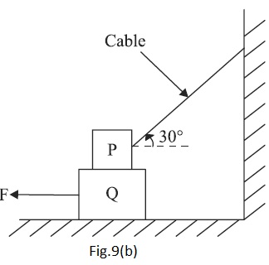 | CO5 | (12)
10. | a) | Define:  - Rectilinear motion with example  - Curvilinear motion with example. | CO5 | (08)
 | b) | A cricket ball thrown by a player from a height of 2.0 m above the horizontal ground at an angle of 30º to the horizontal and with a velocity of 12m/s. The ball hits the wicket at a height of 0.6m above the ground. How far is the player from the wicket? | CO5 | (12)

****************

